**Simple-Dapp Example Manual**

Step 1. Download simple-Dapp example from

<https://github.com/frozeman/simple-dapp-example/blob/master/README.md>, then unzip it to any directory you want, but you have to know the path.

Step 2. Edit file at simple-dapp-example-master/app/client folder

1. ethereum-connector.js, line 3

*web3 = new Web3(new Web3.providers.HttpProvider("http://localhost:8545"));*

1. ethereum-contract.js, line 5

*GuessNumberInstance = GuessNumber.at('0x50c37e89bA4C1Df49f86aB057BBD6ce30b703Dd4');*

'0x50c37e89bA4C1Df49f86aB057BBD6ce30b703Dd4' is our contract address on testnet.

Step 3. Install 6 following packages uses terminal commands

1. meteor add meteor-platform

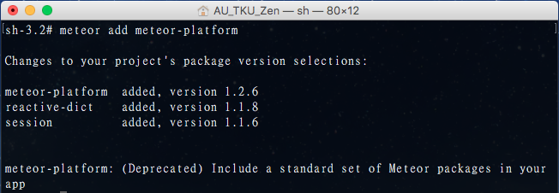

1. meteor add autopublish

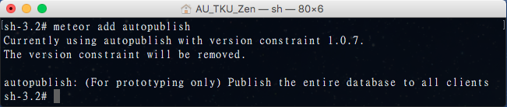

1. meteor add insecure

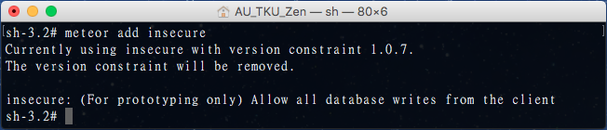

1. meteor add ethereum:web3

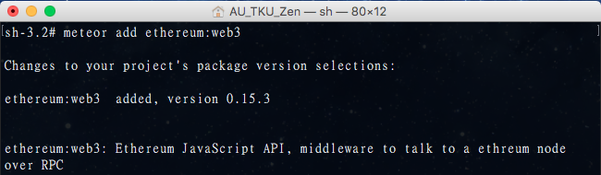

1. meteor add frozeman:template-var

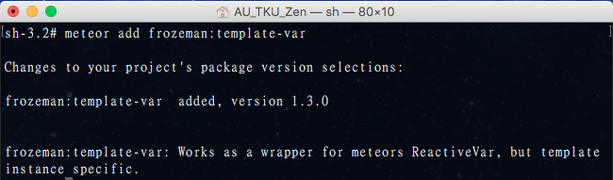

1. meteor add frozeman:persistent-minimongo

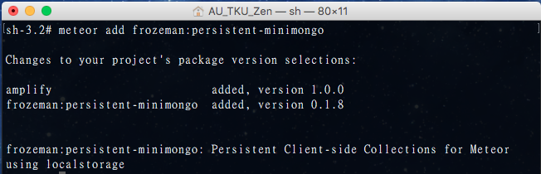

Step 4. While all packages and files are settle-down, now we’ll link to “testnet”(Ethereum provides “mainnet”, “testnet” and “privatenet”, we use testnet on our project), type the command:

*geth --testnet --rpc --rpccorsdomain “*” --rpcapi “eth,web3,net,personal”*

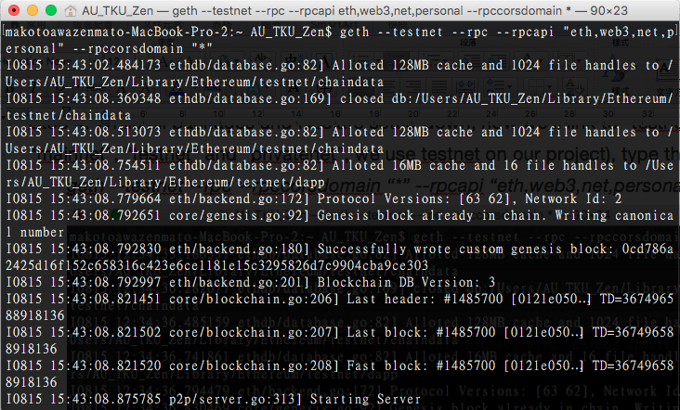

When the command executes, it will setup the testnet environment and synchronize all the blocks in testnet automatically.

1. --rpc : This will enable RPC interface on your node. This is generally enabled by default in geth.
2. --rpccordsdomain “*” : This dictates what URLs can connect to your node in order to perform RPC client tasks. Be very careful with this and type a specific URL rather than he wildcard (*) which would allow any URL to connect to our RPC instance.
3. --rpcapi : enable APIs we choose, the “personal” API we’ll use to unlock our account.

* If you can’t use “geth” command, you have to install “Homebrew” first and then use Homebrew installs ethereum, see the comment below

Step 5. While we successfully link to testnet, now we use command “cd” move to the simple-dapp-example folder, enter to app/client folder, then type command “meteor” to compile the code.

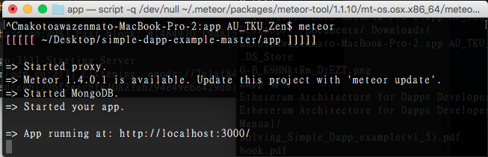

Now we can see the result at our browser, the site is “localhost:3000”

**Preceding Procedure**

Step 1. Install Homebrew on MAC

The **Go** implementation is called **Geth**. Geth has been audited for security and will be the future basis for the enduser-facing **Mist Browser**, so if you have experience with web development and are interested in building frontends for dapps, you should experiment with Geth.

Install [Homebrew](brew.sh)

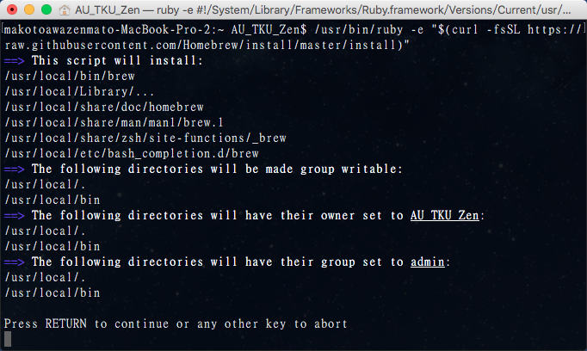

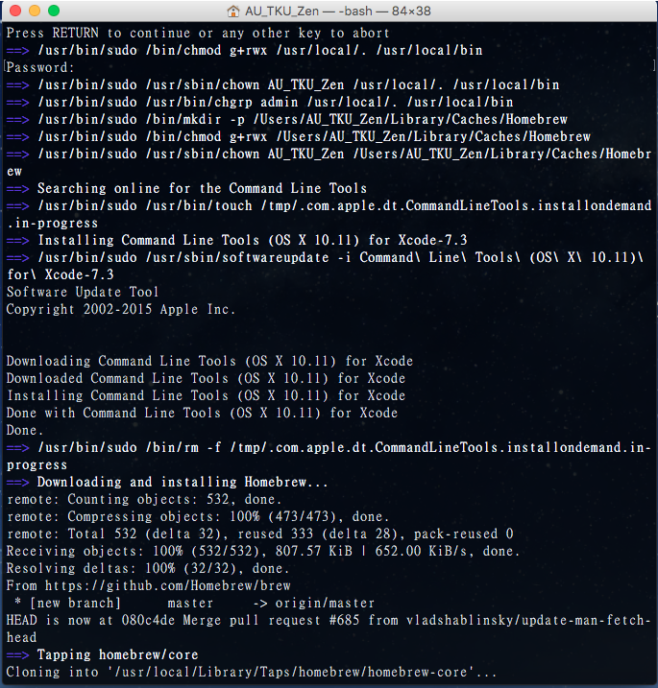

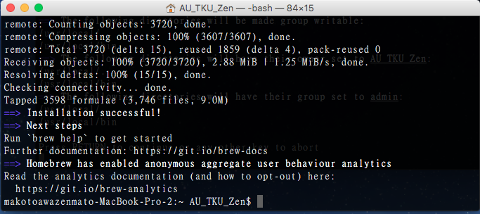

and make sure it’s up to date.

*brew update*

*brew upgrade*

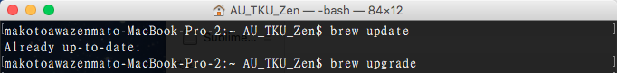

Homebrew is a free and open-source software package management system that simplifies the installation of software on Apple’s OS X operation system.

Step 2. Use these commands to install ethereum:

brew tap ethereum/ethereum

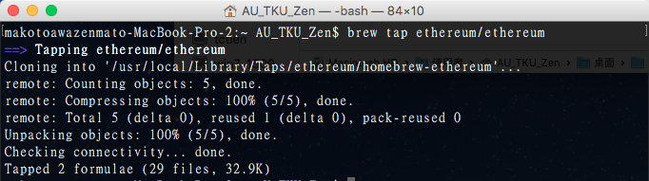

brew install ethereum

